
Griffith College Dublin

COMPUTING ASSIGNMENT TITLE SHEET

Course: B.Sc. in Computing (Level 7 and Level 8)
Stage/Year: I
Module: Computer Programming
Semester: II
Assignment Number: Take Home Assignment 3
Date of Title Issue: 9/3/16
Assignment Deadline: 30/3/16
Assignment Submission: Submitted on Moodle
Assignment Weighting: 15%

Assignment Title

Ludo Game

Ludo is a board game for two to four players, in which the players race their four tokens from start to finish according to dice rolls

Your task is to implement this game in Java. Your output should other be a console based Java program.

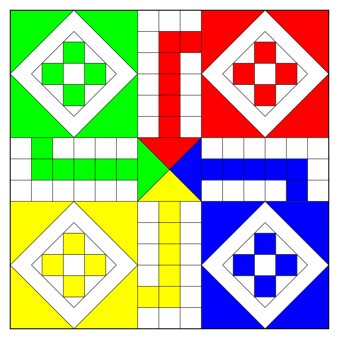

Game Rules
Each throw, the player decides which piece to move. A piece simply moves in a clockwise direction around the track given by the number thrown. If no piece can legally move according to the number thrown, play passes to the next player.

A throw of 6 gives another turn.

A player must throw a 6 to move a piece from the starting circle onto the first square on the track. The piece moves 6 squares around the circuit beginning with the appropriately coloured start square (and the player then has another turn).

If a piece lands on a piece of a different colour, the piece jumped upon is returned to its starting area.

If a piece lands upon a piece of the same colour, this forms a block. This block cannot be passed or landed on by any opposing piece.

Winning

When a piece has circumnavigated the board, it proceeds up the home column. A piece can only be moved onto the home area by an exact throw.

The first person to move all 4 pieces into the home area wins.

Deliverables:
For this assignment you are required to submit 2 pieces of work:
- Java file containing your program (70%)
- A flow chart to show your design of the program (30%)

Learning Outcomes
- solve programming problems of modest complexity in a systematic, well- organised way
- specify precisely the syntax and semantics of a programming language construct
- select an appropriate program construct (or datatype) to achieve a given task
- document accurately the design of a program on-the-fly

Assessment Criteria
Grading Matrix | % |  | Grading Matrix |  | %
Game System | 60 |  | User Interface |  | 10
Rolling Dice | 2 |  | Game style layout |  | 3
Adding player token | 5 |  | Display current board |  | 5
Moving token | 2 |  | User feedback |  | 2
Game ending turn | 3 |  | Coding Style |  | 20
Continue playing | 4 |  | Indentation |  | 3
Turn based system | 4 |  | Comments |  | 4
Reading from text files | 5 |  | Use of Methods |  | 3
Writing to text files | 5 |  | Use of 2D arrays |  | 5
Using a 2d Array to store the board | 5 |  | Use of Text Files |  | 5
Moving token onto the board | 6 |  | Extra Features |  | 10
Moving token into finish area. | 4
Moving token back to start area | 5
Creating a block | 10

